Saguaro National Park

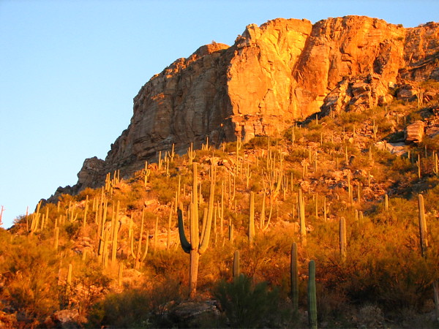

To-Do List:

* Sabino Canyon: Super pretty scenes and is North of Tuscon
* Colossal Cave: About 22 miles southeast of Tuscon, with 3.5 miles of mapped passageways
* Gila monsters: One of the only 2 venomous lizards in the world! Most active during the day and are found in the desert.
* Signal Hill trail: Here in the West part, you can see ancient petroglyphs! Be ready for a climb up 150 stairs!
* Freeman Homestead trail: A 1 mile trail that leads to a saguaro cactus grove. It is unpaved, but looks pretty.